**Summary 2:**

**A gesture system for graph visualization in virtual reality environments**

The study proposes the use of gestures to interact with graphs in VR and test the usability of such a system against traditional mouse control. Gestures were designed for eight operations intended to cover most selection operations used in terms of both intuitively and feasibility. User’s hand motion (obtained through Leap Motion) is displayed in the VR environment as feedback. A group of 14 users were selected and split in to two equal groups with roughly same abilities. Each user preforms nine tasks on three different graphs of different complexities (brain graphic, force direction graph, and bio layout graph). Both groups are given time to practice until the felt comfortable with the operations. Results found that gestures made it easier to move nodes and edges rotating the graph, however, the performance was worse for grouping operations, perhaps due to it’s complexity (just change from single to double click for mouse). Users performed much better as the complexity of the graph increased, likely due to the ease of manipulation using gestures. User group agreed that the gestures were simple and intuitive. Some of the gestures made be redesigned considering ergonomics (comfort and fatigue level).

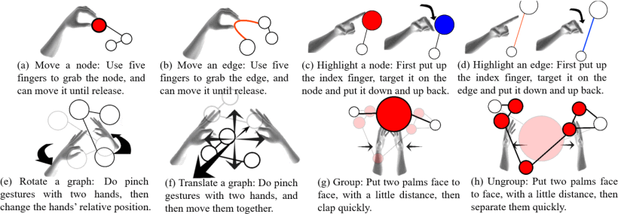

**Set of gestures designed for experiment. (Taken from article to provide further context)**

**BibTeX:**

@INPROCEEDINGS{8031577,   
author={Yi-Jheng Huang and T. Fujiwara and Yun-Xuan Lin and Wen-Chieh Lin and Kwan-Liu Ma},   
booktitle={2017 IEEE Pacific Visualization Symposium (PacificVis)},   
title={A gesture system for graph visualization in virtual reality environments},   
year={2017},   
volume={},   
number={},   
pages={41-45},   
abstract={As virtual reality (VR) hardware technology becomes more mature and affordable, it is timely to develop visualization applications making use of such technology. How to interact with data in an immersive 3D space is both an interesting and challenging problem, demanding more research investigations. In this paper, we present a gesture input system for graph visualization in a stereoscopic 3D space. We compare desktop mouse input with gesture input with bare hands for performing a set of tasks on graphs. Our study results indicate that users are able to effortlessly manipulate and analyze graphs using gesture input. Furthermore, the results also show that using gestures is more efficient when exploring the complicated graph.},   
keywords={data visualisation;graph theory;virtual reality;VR;gesture system;graph visualization;stereoscopic 3D space;virtual reality;Data visualization;Electronic mail;Mice;Resists;Three-dimensional displays;Two dimensional displays;Visualization;H.5.2 [Information Systems]: Information Interfaces and Presentation—User Interfaces},   
doi={10.1109/PACIFICVIS.2017.8031577},   
ISSN={},   
month={April},}